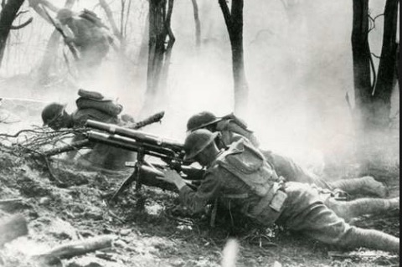
RLymYC Winter lectures
20 March at 18.30 in the Island Room

The Battle of the Somme
Rhydian Vaughan

The battle of the Somme is often painted as a huge failure with enormous casualties. However, the battle was described by a German staff officer as “the muddy grave of the German Army and the loss of belief in the German High Command”. In March of 1917, the German Army retreated 25 miles to the newly prepared Hindenburg Line. The battle, from 1st July to 17th November 1916 certainly ‘shaped’ the British Army so that by 1918, it was the finest and most effective in Europe.

